Task 3: Virtualization, Installation of Virtual Machine Software and installation of Operating System on Virtual Machine.

Virtualization is a technology that allows you to create multiple simulated environments or virtual machines (VMs) on a single physical hardware system. It essentially means running multiple operating systems and applications on one physical server or computer.

*Here are the key aspects:*

**How It Works**

1. **Hypervisor**: The core component of virtualization is the hypervisor, also known as a virtual machine monitor (VMM). The hypervisor sits between the physical hardware and the virtual machines, managing resources and ensuring isolation between VMs.
2. **Virtual Machines**: These are the simulated environments created by the hypervisor. Each VM behaves like a separate computer, complete with its own operating system, applications, and resources.

**Types of Virtualization**

* **Server Virtualization**: Multiple virtual servers run on a single physical server, optimizing resource usage and reducing costs.
* **Desktop Virtualization**: User desktops are virtualized and hosted on a central server, allowing access from any device.
* **Application Virtualization**: Applications are virtualized and run in isolated containers, ensuring compatibility and security.
* **Network Virtualization**: Network resources are abstracted and managed as virtual entities, improving flexibility and scalability.
* **Storage Virtualization**: Storage resources are pooled and managed as a single entity, enhancing efficiency and management.

**Benefits**

* **Resource Optimization**: Efficiently utilizes hardware resources, reducing the need for additional physical servers.
* **Cost Savings**: Lowers hardware, energy, and maintenance costs by consolidating multiple systems into one.
* **Flexibility**: Allows for easy creation, modification, and deletion of virtual environments.
* **Scalability**: Makes it simple to scale up or down based on demand.
* **Isolation**: Ensures that issues in one VM don't affect others, enhancing security and stability.

**Linux and its distributions (distro):**

Linux is an open-source operating system that's similar to Unix. It's known for its stability, security, and flexibility, making it popular for servers, desktops, and embedded systems.

**Key Features of Linux**

* **Open Source**: The source code is freely available, allowing anyone to study, modify, and distribute it.
* **Security**: Linux is less susceptible to malware and viruses compared to some other operating systems.
* **Stability**: Known for its robustness and reliability, often used in mission-critical environments.
* **Community Support**: Extensive support from a global community of developers and users.

**Popular Linux Distributions**

Linux distributions, or "distros," package the Linux kernel with different sets of software and tools. Here are some popular distributions:

**1. Ubuntu**

* **Target Audience**: General users, beginners, and enterprises
* **Features**: User-friendly, large software repository, strong community support

**2. Fedora**

* **Target Audience**: Developers, tech enthusiasts
* **Features**: Cutting-edge technology, sponsored by Red Hat, great for development

**3. Debian**

* **Target Audience**: Stability-focused users
* **Features**: Extremely stable, large repository, basis for many other distros (including Ubuntu)

**4. CentOS**

* **Target Audience**: Servers, enterprises
* **Features**: Community-supported, enterprise-level stability (based on Red Hat Enterprise Linux)

**5. Arch Linux**

* **Target Audience**: Advanced users
* **Features**: Highly customizable, rolling releases, user-centric

**Minimum Hardware Requirements for Kali Linux:**

* **Processor**: 2 GHz dual-core
* **RAM**: 4 GB (for physical installs), 2 GB (for virtualized installs)
* **Storage**: 25 GB of hard drive space (or USB stick, memory card, or external drive)
* **Display**: VGA capable of 1024×768 screen resolution

**Install linux OS by using virtualization**

**Choose Virtualization Software**

Select a virtualization software to create and manage virtual machines (VMs). Popular options include:

* **VirtualBox**: Free and open-source
* **VMware Workstation Player**: Free for non-commercial use
* **Hyper-V**: Built into Windows 10 Pro and Enterprise editions

Oracle VirtualBox is a powerful and user-friendly virtualization software.

**Steps of** **installing**:

**Step 1: Download and Install VirtualBox**

1. Go to the Oracle VirtualBox website https://www.virtualbox.org/ and download the installer for your operating system (Windows, macOS, or Linux).
2. Install VirtualBox by following the on-screen instructions.

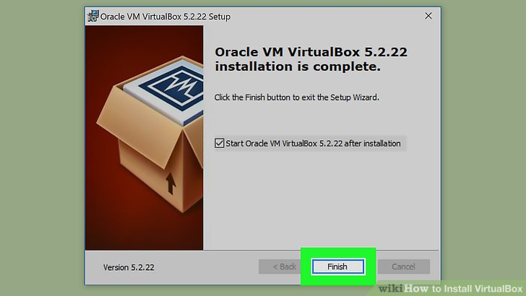

Fig: installing virtual box

**Step 2: Download the Linux ISO**

1. Download the ISO file for the Linux distribution you want to install (e.g., Ubuntu, Kali Linux) from the official website of the distribution.

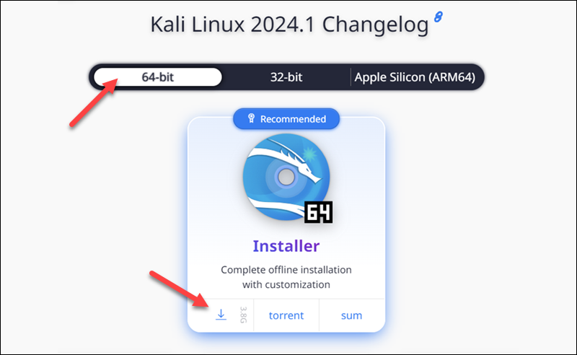

Fig: Downloading kali linux iso image file

**Step 3: Create a New Virtual Machine**

1. Open VirtualBox and click on the “New” button.

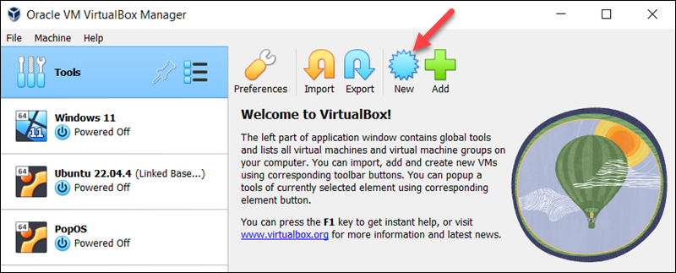

1. Enter a name for your virtual machine (e.g., “Kali”).

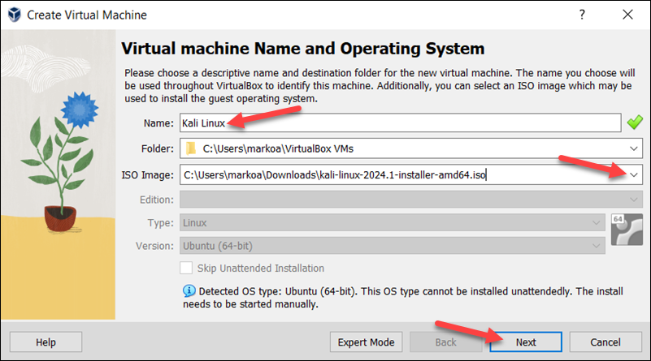

1. Choose the type of operating system (Linux) and the version (Ubuntu, Kali Linux, etc.).
2. Allocate memory (RAM) to the virtual machine (e.g., 2048 MB or more).

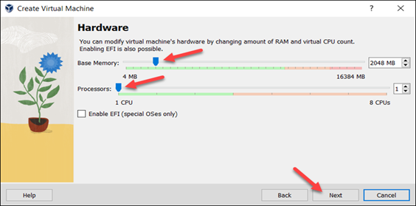

1. Create a virtual hard disk by selecting “Create a virtual hard disk now” and choosing the file type (VDI), storage on physical hard disk, and size (e.g., 20 GB or more).

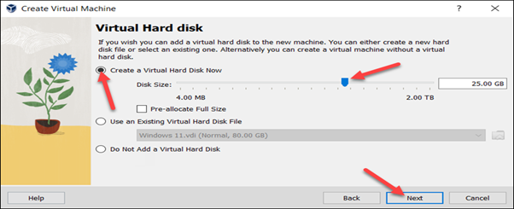

**Step 4: Configure the Virtual Machine**

1. Go to the settings of the virtual machine and adjust the following:
   * **System**: Enable “Enable I/O APIC” and “Enable Nested VT-x/AMD-V” if available.
   * **Processor**: Allocate the number of processors (e.g., 2).
   * **Display**: Adjust the video memory (e.g., 128 MB) and enable “Enable 3D Acceleration” if available.
   * **Storage**: Click on the “Empty” CD/DVD drive and click on the disk icon to add the Linux ISO file you downloaded.

**Step 5: Start the Virtual Machine and Install Linux**

1. Click on the “Start” button to boot the virtual machine from the ISO file.

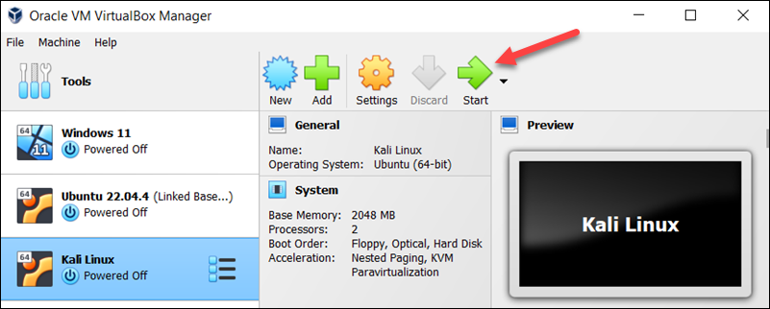

1. Follow the on-screen instructions to install the Linux OS. This will include selecting the installation language, location, keyboard layout, and partitioning the virtual hard disk.
2. Complete the installation process and reboot the virtual machine.

**Step 7: Configure Linux**

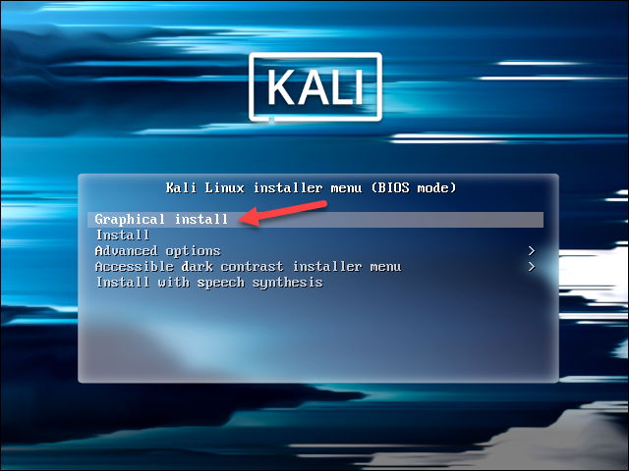

**Fig 4: Perform Initial Configuration**

a)In the **Configure the network** section, enter a **system hostname**.

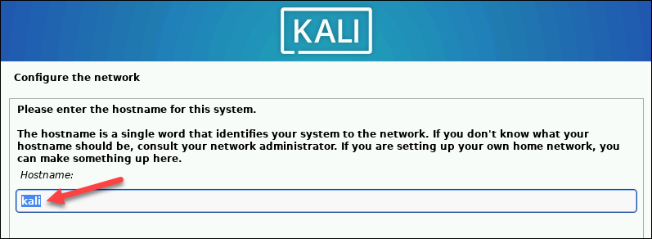

b) Type a **domain name** that the OS will use to identify the VM within a network. Specifying a [**domain**](https://phoenixnap.com/glossary/what-is-a-domain) name is not necessary if the VM is not part of an extensive local network.

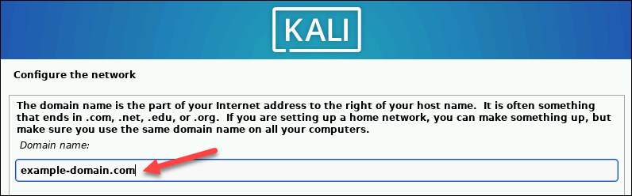

c) Create a **user account** by providing the user's full name and username.

d) Create a [**strong password**](https://phoenixnap.com/blog/strong-great-password-ideas) for the user account.

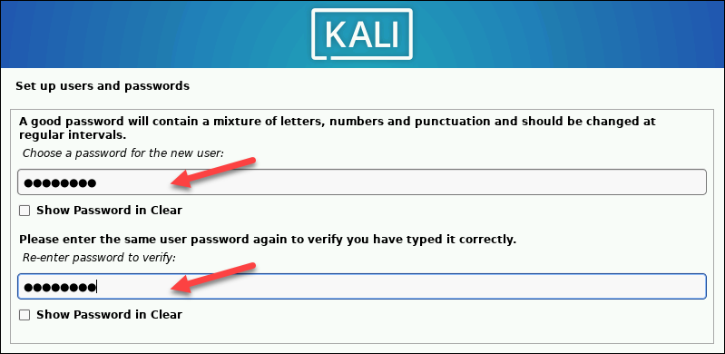

**Step 8: Create Hard Disk Partitions**

Proceed with the following steps to create a bootable partition on the virtual hard disk:

a) Select how to partition the hard disk. The default option is **Guided - use entire** **disk**.

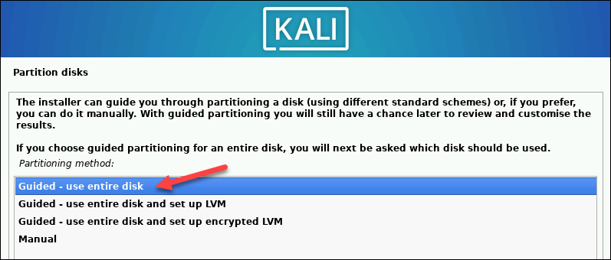

b) Select the disk you want to use for partitioning. The only available option is the disk created during the VM creation.

c) Select the **partitioning scheme**. The default option is **All files in one partition**.

d) The wizard provides an overview of the configured partitions. Ensure that the **Finish partitioning and write changes to disk** option is selected.

e) Confirm the choice by selecting **Yes** on the next screen.

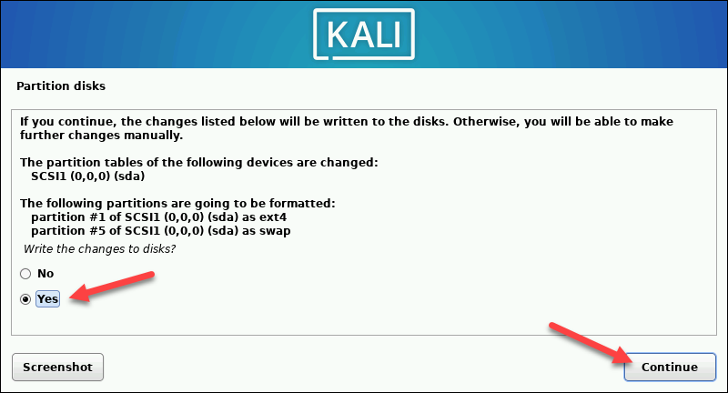

**Step 9: Customize Kali Linux Installation:**

After installing the system's core, Kali enables users to customize the OS further. Choose the components to install by executing the following steps:

a) Select the desktop environment and the tools you want or click **Continue** to proceed with the default options.

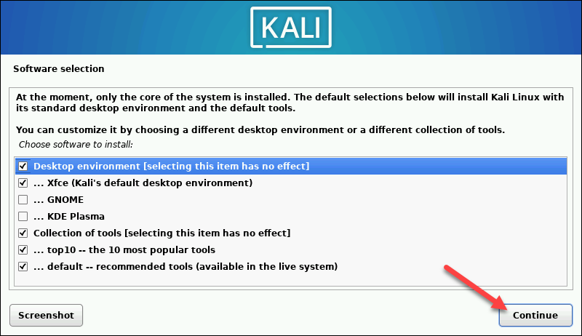

b) Select whether you want to use a network mirror.

c) If you use an **HTTP proxy**, enter the necessary information. Otherwise, leave the field blank.

d ) Install**the GRUB bootloader** on the hard disk. Select **Yes** and **Continue**.

e) Select a bootloader device to ensure the newly installed system is bootable.

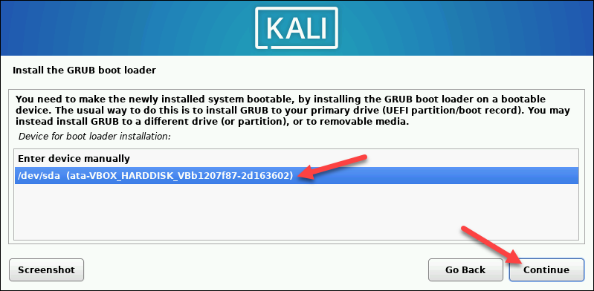

***When Kali finishes installing, the Installation is complete message appears.***

f) Click **Continue**to reboot your VM. After rebooting, the Kali login screen appears.

g) Enter the username and password created in the previous steps.

**The Kali Linux desktop appears on the screen.**

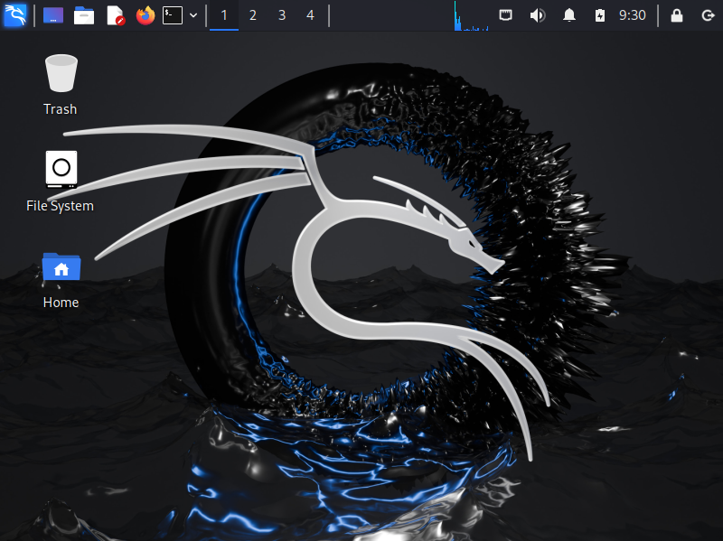

Fig: The Kali Linux desktop appears on the screen

After installing Linux, update your system using sudo apt update && sudo apt upgrade, and install essential software like Firefox and VLC using your package manager.